Lab 03: Logic Minimization with Karnaugh Maps

Joseph Martinsen

ECEN 248 – 510

TA: Michael Bass

Date: September 26, 2016

**Objectives:**

The purpose of this lab is to create a very simple real life scenario where digital electronics and a basic circuit is able to simplify the process. The use of a truth table with four inputs and three outputs is utilized. In order to simplify the circuit, creating a Kernaugh map is used. The Kernaugh map allows for easy creation of a SOP-equation. The SOP-equation is then used to create a circuit.

**Design:**

The following are the requirements for how points are gained or lost depending on the types of animals bred on the farm:

1. He can raise cows, sheep, hogs, and chickens on his farm but cannot raise all at the same time.

2. The farm does not have enough space to raise more than 2 different types of animals. Therefore, his

farm never has more than 2 types of animals at any particular time.

3. Each type of the animal earns a certain level of profit for the farm. Cows earn him a profit of 4 units, sheep earn him a profit of 2 units, hogs earn a profit of 3 units and chickens being small livestock earn him a profit of 1 unit.

4. The total profit of the farm is the sum of profits made by each type of animal that is raised with the exceptions provided below.

5. Hogs and chickens have very different food, so John needs to spend extra for the transportation of food for each separately. Therefore, if he plans to raise hogs and chickens together then his profits go down by 1 unit.

6. Similarly, if he raises cows and chickens his profits go down by 1 unit because of extra transportation costs. Additionally, cows have a tendency to kill some chickens on the farm. This further reduces his profits by 1 unit.

7. However, cows and sheep do very well if raised together. They have many similarities especially with respect to the kind of food they eat. Also due to the huge demand for sheep and cows, the profit they make goes up by 1 unit if cows and sheep are reared together

The following (*table 1*) is based on how points are distributed. P2 is the most important digit while P0 is the least important digit for the output. I stands for chickens, S for sheep, C for cow, and H for hog. X represents “don’t care” values.

|  |  |  |  |  |  |  |  |  |
| --- | --- | --- | --- | --- | --- | --- | --- | --- |
| **Lab 3 Truth Table** | | | | | | | | |
|
| I (Chicken) | S (Sheep) | C (Cow) | H (Hog) | P2 | P1 | P0 | VALUE |
| 0 | 0 | 0 | 0 | 0 | 0 | 0 | 0 |
| 0 | 0 | 0 | 1 | 0 | 1 | 1 | 3 |
| 0 | 0 | 1 | 0 | 1 | 0 | 0 | 4 |
| 0 | 0 | 1 | 1 | 1 | 1 | 1 | 7 |
| 0 | 1 | 0 | 0 | 0 | 1 | 0 | 2 |
| 0 | 1 | 0 | 1 | 1 | 0 | 1 | 5 |
| 0 | 1 | 1 | 0 | 1 | 0 | 1 | 5 |
| 0 | 1 | 1 | 1 | X | X | X | X |
| 1 | 0 | 0 | 0 | 0 | 0 | 1 | 1 |
| 1 | 0 | 0 | 1 | 1 | 0 | 0 | 4 |
| 1 | 0 | 1 | 0 | 0 | 1 | 1 | 3 |
| 1 | 0 | 1 | 1 | X | X | X | X |
| 1 | 1 | 0 | 0 | 0 | 1 | 1 | 3 |
| 1 | 1 | 0 | 1 | X | X | X | X |
| 1 | 1 | 1 | 0 | X | X | X | X |
| 1 | 1 | 1 | 1 | X | X | X | X |
| *Table 1* | | | | | | | | |

The following table (*table 2*) is the transformation of the table into a Kernaugh Map for P0

|  |  |  |  |  |  |  |
| --- | --- | --- | --- | --- | --- | --- |
| **P0** | | | | | | |
|
|  |  |  |  | S | |  |
|  |  |  |  |  | I | |
|  |  |  |  |  |  |  |
|  |  |  | 0 | 0 | 1 | 1 |
| H |  |  | 1 | 1 | X | 0 |
| C |  | 1 | X | X | X |
|  |  | 0 | 1 | X | 1 |

*Table 2*

The equation derived from this Kernaugh Map is: $P0=I+H+CS$

The following table (*table 3*) is the transformation of the table into a Kernaugh Map for P1

|  |  |  |  |  |  |  |
| --- | --- | --- | --- | --- | --- | --- |
| **P1** | | | | | | |
|
|  |  |  |  | S | |  |
|  |  |  |  |  | I | |
|  |  |  |  |  |  |  |
|  |  |  | 0 | 1 | 1 | 0 |
| H |  |  | 1 | 0 | X | 0 |
| C |  | 1 | X | X | X |
|  |  | 0 | 0 | X | 1 |
| *Table 3* | | | | | | |

The equation derived from this Kernaugh Map is: $P0=\overline{S}H+S\overline{H}+IC$

The following table (*table 4*) is the transformation of the table into a Kernaugh Map for P2

|  |  |  |  |  |  |  |
| --- | --- | --- | --- | --- | --- | --- |
| **P2** | | | | | | |
|
|  |  |  |  | S | |  |
|  |  |  |  |  | I | |
|  |  |  |  |  |  |  |
|  |  |  | 0 | 0 | 0 | 0 |
| H |  |  | 0 | 1 | X | 1 |
| C |  | 1 | X | X | X |
|  |  |  | 1 | 1 | X | 0 |
|  |  |  | *Table 4* | | | |

The equation derived from this Kernaugh Map is: $P2=\overline{I}C+SH$

The following diagram is of the circuit implantation of the equations of P0, P1, and P

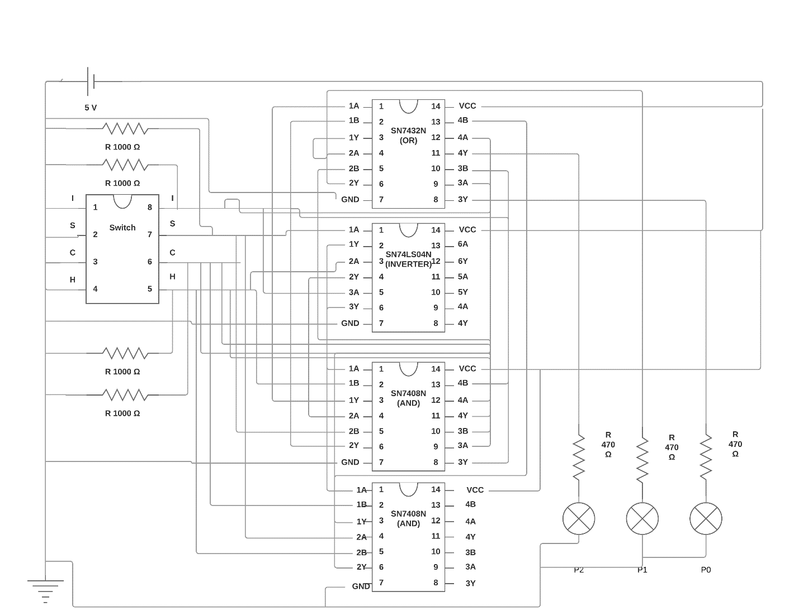The following has the outputs of P0, P1, and P2 going into a decoder then into a seven-segment display instead of 3 separate LEDs.



The following is the decoder used (SN74LS47):



A corresponds to P0, B to P1, C to P2, and D was connected to ground because in this lab, it was always 0 because no number output was greater than 7. The letters on the right is associated with the following on the display:



**Results:**

*Use this section to discuss the observations you made during the lab. Include a comparison of what you expected to what you actually observed and provide an in-depth discussion of why you feel the circuit you built behaved the way it did. Like the design section, include diagrams and tables where appropriate. Be sure to label them properly and provide an adequate description in the body of the text.*

The circuit created during the lab period was able to light up the P0 and P2 light correctly but as it was not finished, it will not be discussed. The circuit that will be discussed will be the one created on Saturday.

The circuit created was exactly the same as the one in depicted in the circuit diagram. There were issues early on with the inverter. After setting up P2, it was noticed that the inverter was not actually inverting anything. With a 0.2 voltage going into the output, the inverted value was 0.5 volts. After testing multiple wires, I was finally able to come to the conclusion that the inverter needed to be replaced. After replacing it, inverter values were in the range of 4.4 Volts.

A similar issue occurred with an AND gate where 3Y was not outputting correctly. I was not able to determine if it was an issue with input or output so the IC was replaced.

The following values were the results that were different than the *Table 1*

|  |  |  |  |  |  |  |  |
| --- | --- | --- | --- | --- | --- | --- | --- |
| I (Chicken) | S (Sheep) | C (Cow) | H (Hog) | P2 | P1 | P0 | VALUE |
| 0 | 0 | 0 | 1 | 1 | 0 | 1 | 5 |
| 0 | 1 | 0 | 0 | 1 | 1 | 0 | 6 |
| 1 | 0 | 0 | 0 | 0 | 1 | 1 | 3 |
| 1 | 0 | 0 | 1 | 0 | 1 | 0 | 2 |

After testing different cables, I would be able to fix one but another seems to messed up. This final setup was the one with the best results.

When it came to the 7-segment display, two different displays were used but both with the same results, none of the segments would turn on. The setup were as follows, the cables a,b,c,d,e,f, and g coming out of the decoder were each placed in series with a different 470 ohm resistor. After passing through the resistor, the cables were then connected to the display. Even without a decoder and having the cable from the power source pass through a resistor and then into the display, it would still not light up any of the lights. I am not able to conclude whether the issue was my lack of knowledge or because the two displays were previously fried.

**Conclusion:**

In conclusion, only about 85% of the lab was completed correctly. Through much debugging and troubleshooting, I was able to become very familiar with how logic gates function as well as gain an understanding as to how to debug.

**Questions:**

**1. Make a table showing the digital inputs and outputs of your circuit observed during lab. For input combinations not allowed by the aforementioned guidelines, provide the output values observed rather than ‘X’.**

**2. Provide a comparison between the table in item 1 and the truth table you created in the pre-lab. What values does your circuit output for the “don’t cares” and why?**

The following are the values from my circuit that were different

|  |  |  |  |  |  |  |  |
| --- | --- | --- | --- | --- | --- | --- | --- |
| I (Chicken) | S (Sheep) | C (Cow) | H (Hog) | P2 | P1 | P0 | VALUE |
| 0 | 0 | 0 | 1 | 1 | 0 | 1 | 5 |
| 0 | 1 | 0 | 0 | 1 | 1 | 0 | 6 |
| 1 | 0 | 0 | 0 | 0 | 1 | 1 | 3 |
| 1 | 0 | 0 | 1 | 0 | 1 | 0 | 2 |

The following values were outputted from my circuit when there where X’s in the original truth table

|  |  |  |  |  |  |  |  |
| --- | --- | --- | --- | --- | --- | --- | --- |
| I (Chicken) | S (Sheep) | C (Cow) | H (Hog) | P2 | P1 | P0 | VALUE |
| 0 | 1 | 1 | 1 | 1 | 0 | 1 | 5 |
| 1 | 0 | 1 | 1 | 0 | 1 | 1 | 3 |
| 1 | 1 | 0 | 1 | 1 | 0 | 1 | 5 |
| 1 | 1 | 1 | 0 | 0 | 1 | 1 | 3 |
| 1 | 1 | 1 | 1 | 1 | 1 | 1 | 7 |

**3. Derive the Product of Sum (POS) expression for a 3-input (A, B, C) XNOR Gate. Assume that output of the gate is called ‘Y’.**

**4. Figure 7 labels the driver output as having an open-collector output. Explain what this means. Consult the datasheet for more information.**

An open collector is a type of output found on many integrated circuits (IC). Instead of outputting a signal of a specific voltage or current, the output signal is applied to the base of an internal NPN transistor whose collector is externalized (open) on a pin of the IC­1.

1 - http://www.evilmadscientist.com/2012/basics-open-collector-outputs/